Queen’s Jewelry and Pawnshop System
user’s Manual
admin
2026
Contents
Logging In 2
User types 2
Dashboard 3
Branch records 3
Term Duration 4
Days Before Maturity 4
Days Before Expiration 5
Other Fees 5
Service Charge 6
Penalty Rate 6
Advanced Interest Rates 7
Interest Rates 7
Expense Category 8
Clients 9
Pawn Tickets 11
Pawn List 15
Pawn details 16
Renew ticket 17
Redeem ticket 18

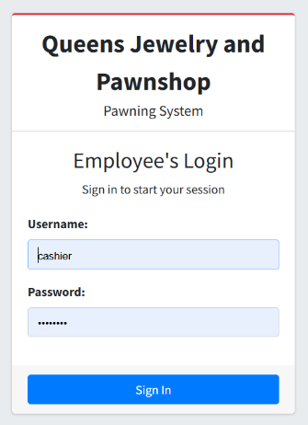
Logging In
- Navigate to the login page provided to you, as shown below
- Once the page shows, enter your username and password.
- Click the Sign In button.
- You will be navigated to the dashboard.

User types
There are four different user types in the system, each of which have their own access to the transactions within the system:
- Cashier. They will have access to the records within their assigned branch; thus, each branch will have their own cashier. Should a cashier be later assigned to another branch, this should be reflected in the system as well. System access includes client records, pawn tickets, daily cash position, and cash count.
- Staff. As one of the back-office personnel, staff will have access to the records of all branches, apart from ticket creation and expense filing.
- Expense Personnel. This is another back-office personnel with focus on expense filing and reports only.
- Administrator. This user will have access to all the features and transactions in the system.

Dashboard
The dashboard shows summary statistics and the latest 10 transactions of the day, all of which have scope depending on the user type. Cashiers, being assigned to a particular branch, will only see statistics and transactions within that branch, while back-office personnel will be able to see the statistics and transactions from all branches.
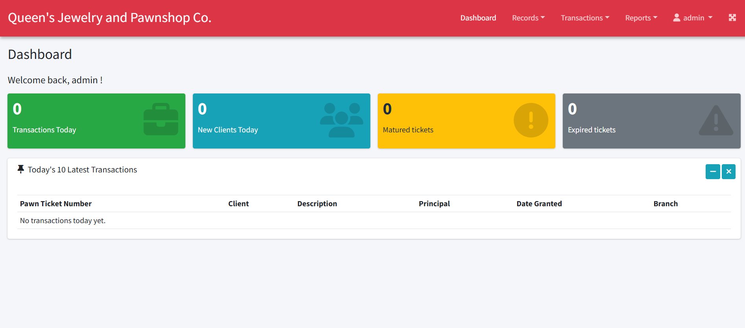

Branch records
The system allows maintaining active branches of Queen’s, provided that the user is non-cashier. Here’s how:
- Navigate to Records > Branches. The page for the branches will be displayed.
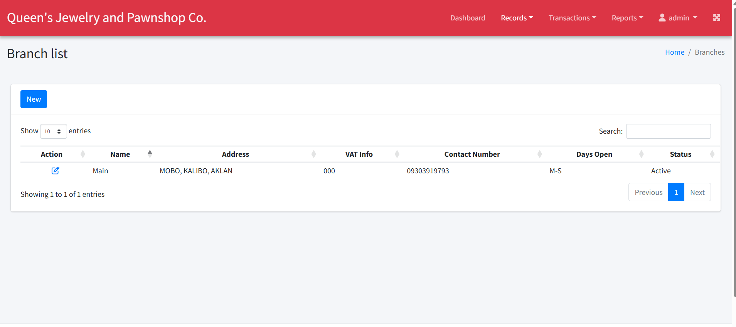
- To create a new branch,
  - click on the New button. The New Branch form will be displayed. 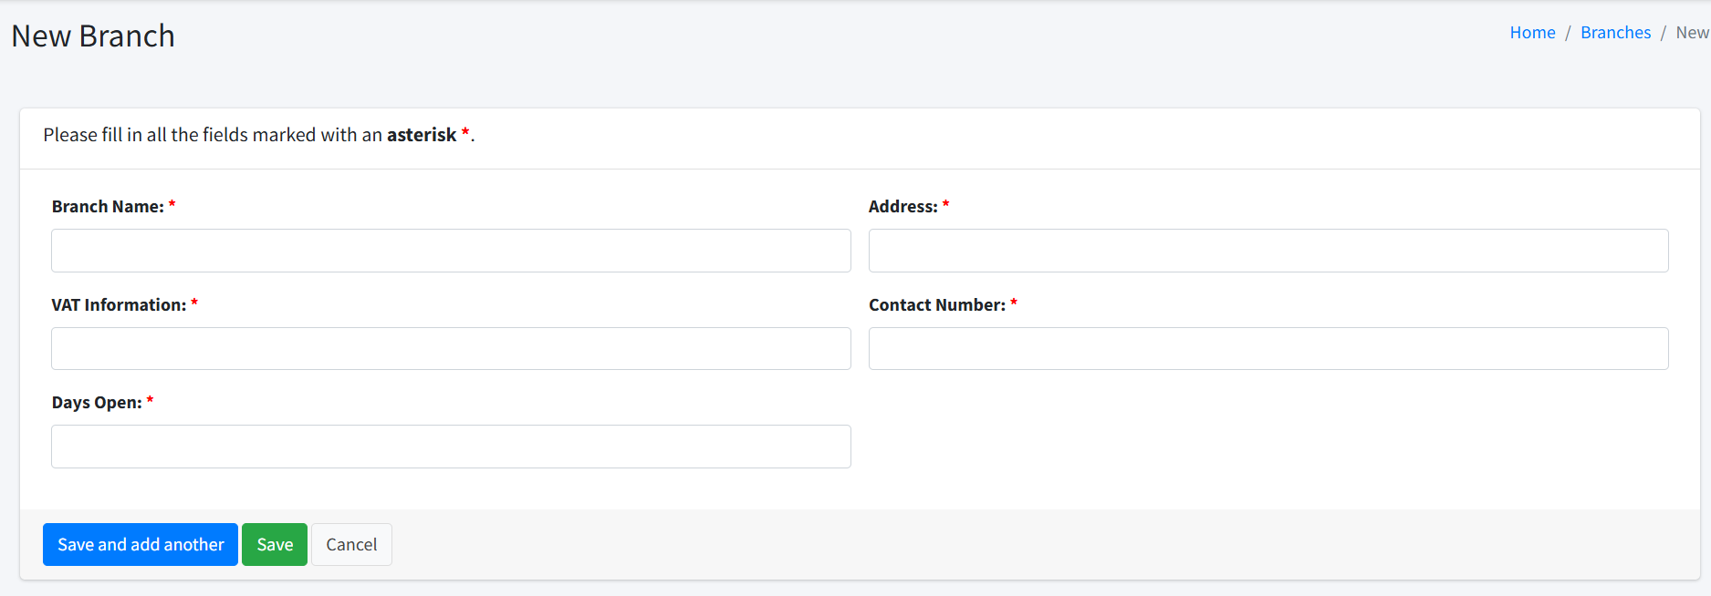
  - Fill out all the required fields.
  - To add another, click Save and add another.
  - To save this record and go back to the list of branches, click the Save button.
  - To cancel the transaction, click the Cancel button.
- To update an existing branch,
  - Click on the Edit icon under the Action column.
  - Modify the form to reflect the updated record.
  - Click on the Save button.

Term Duration
Maintaining term duration allows a non-cashier user to update the number of days before maturity and expiration of all tickets. Tickets past the maturity date will be penalized, while expired tickets may be auctioned.

Days Before Maturity
- Navigate to Records > Term Duration. The Term Duration page appears. 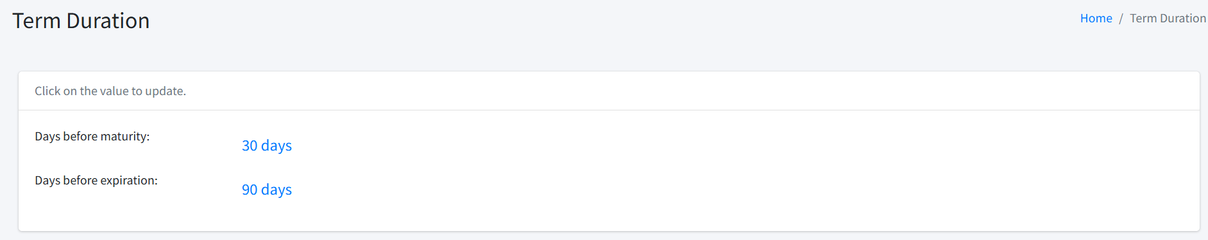
- To change the number of days before maturity, click on the link beside “Days before maturity” (showing 30 days in the above image). The Update maturity modal form will be displayed.
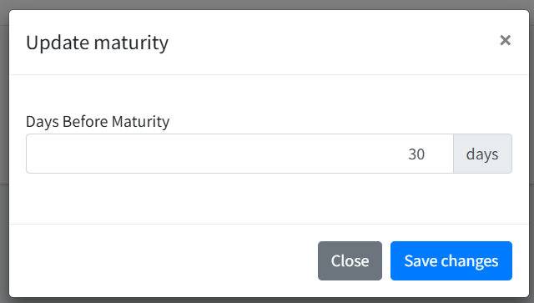
  - Change the number of days before maturity input box.
  - Click the Save changes button to confirm.
  - To cancel, click the Close button.

Days Before Expiration
- Navigate to Records > Term Duration. The Term Duration page appears. 
- To change the number of days before expiration, click the link beside “Days before expiration” (showing 90 days in the above image). The Update expiration modal form will be displayed.
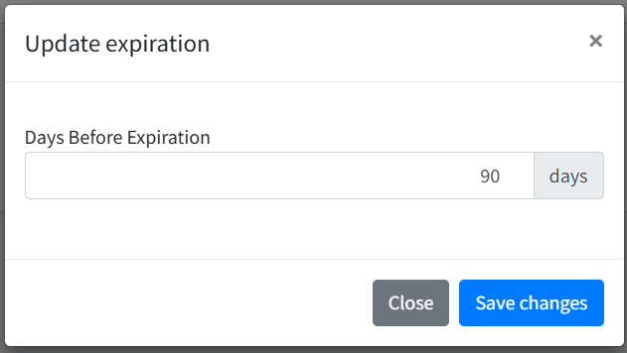
  - Change the number of days before expiration input box.
  - Click the Save changes button to confirm.
  - To cancel, click the Close button.

Other Fees
As for this writing, Other Fees allows non-cashier users to change the service charge and the penalty rate when tickets are renewed or redeemed past their maturity date.

Service Charge
- Navigate to Records > Other Fees. 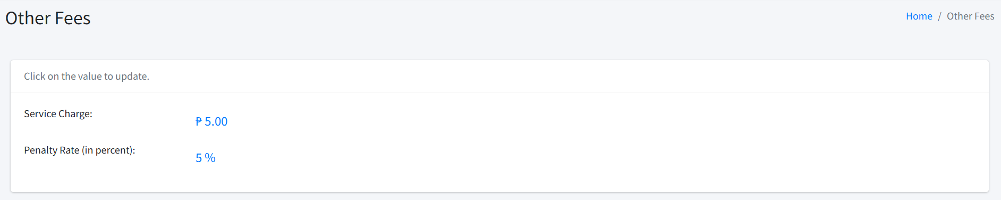
- Click the link beside “Service Charge” (showing 5.00 in the image above). The Update service fee modal form will be displayed. 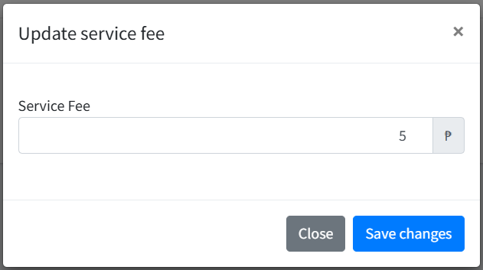
- Enter the updated amount and click Save changes.

Penalty Rate
- Navigate to Records > Other Fees. 
- Click the link beside “Penalty Rate (in percent)” (showing 5% in the image above). The Update penalty rate modal form will be displayed. 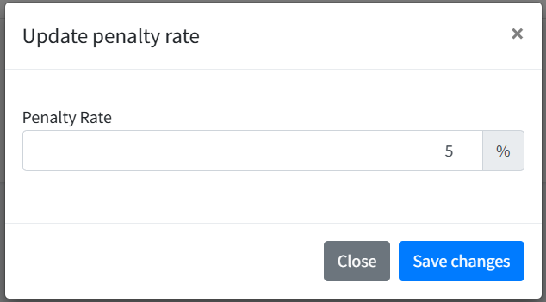
- Enter the updated amount and click Save changes.

Advanced Interest Rates
The system allows an advanced interest rate-based configuration for the pawn tickets, which would require to setup the rates to be applied.
- Navigate to Records > Advance Interest Rates. 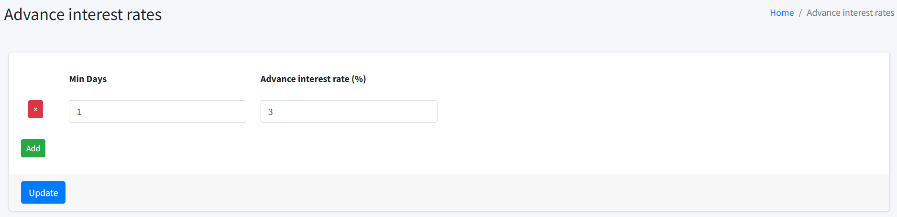
- The Min Days is the number of days when the particular rate will start. Hence, for example, you want to apply the following setup:
1 – 5 days = 1%
6 – 30 days = 3%
then the following should be reflected:
Min Days Advance interest rate (%)
1 1
6 3
- To add a new row, click on the Add button.
- To remove a row, click the X icon beside it.
- To save your changes, click the Update button.

Interest Rates
Interest rates are also referred to as “Accrued interest” in the system, where the interest rate to be applied is based on the elapsed number of days from the ticket was granted until the date it was renewed or redeemed.
- Navigate to Records > Interest Rates. 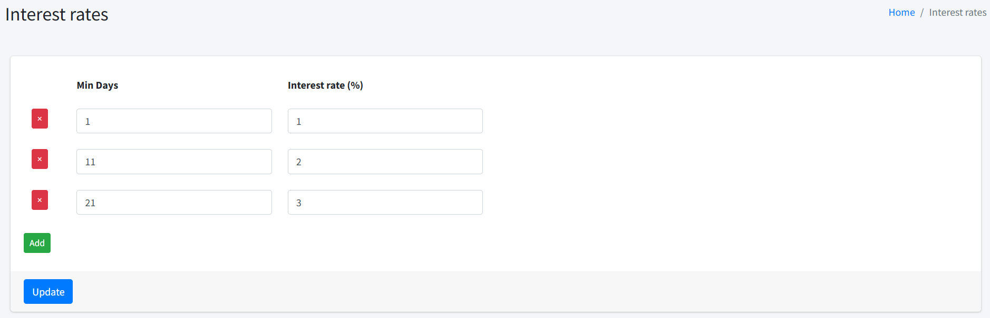
- The Min Days is the number of days when the particular rate will start. Hence, the setup above is for the following:
1 – 10 days = 1%
11 –20 days = 2%
21- 30 days = 3%
- To add a new row, click on the Add button.
- To remove a row, click the X icon beside it.
- To save your changes, click the Update button.

Expense Category
These are the categories of the expenses filed by the expense personnel.
- Navigate to Records > Expense Category. 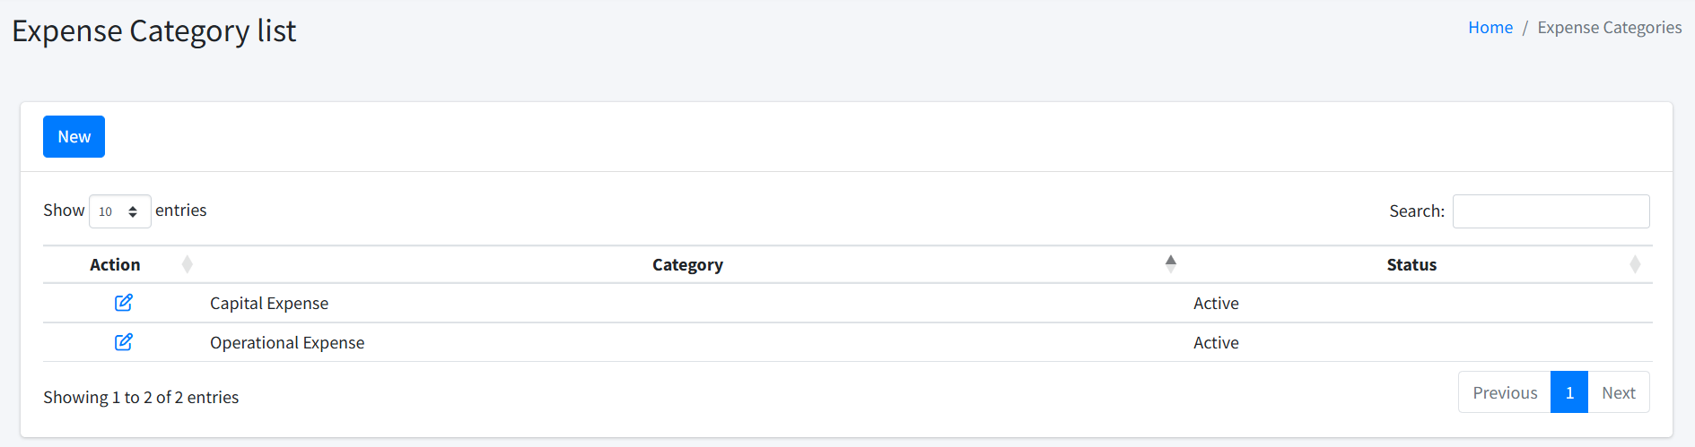
- To add a new category
  - Click the New button. 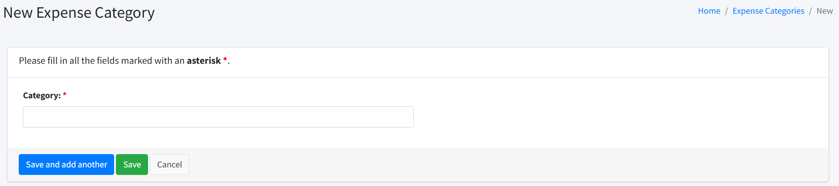
  - Fill out the required fields of the new expense category.
  - To add another, click Save and add another.
  - To save this record and go back to the list of branches, click the Save button.
  - To cancel the transaction, click the Cancel button.
- To update an existing category
  - Click the Edit icon under the Action column.
  - Modify the entry.
  - Click the Save button.

Clients
Keeping accurate records of the clients is imperative to have correct ticket creation and monitoring. When a cashier is logged in, the system filters the client list according to the branch the cashier is assigned. That means, should a client go to another branch, a separate record must be created for him in that branch.
- Navigate to Records > Clients. The client list will be displayed. 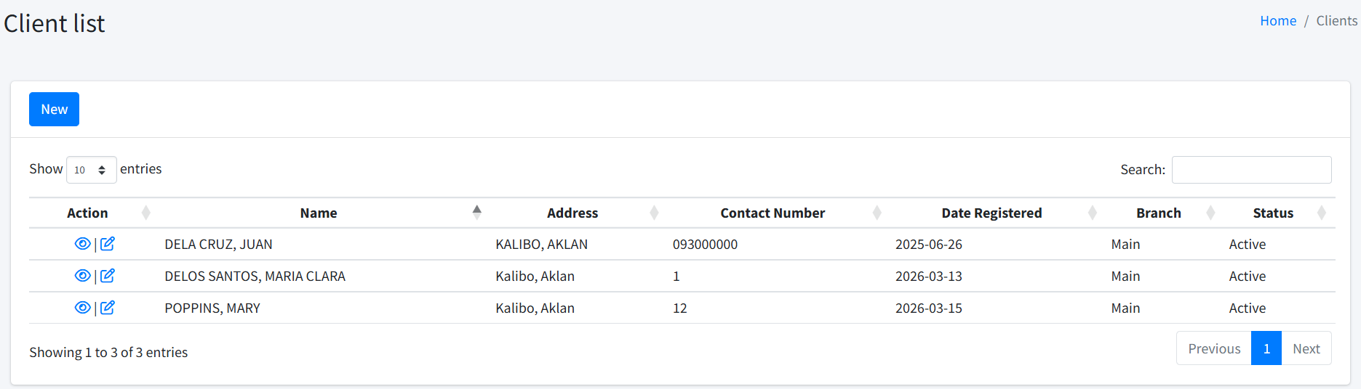
- To add a new client
  - Click the New button. 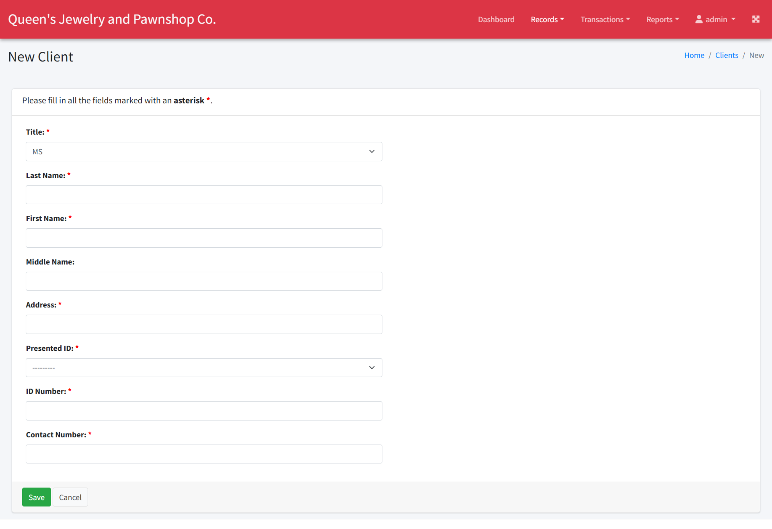
  - Fill in the required fields.
  - Click the Save button.
- To edit an existing client
  - Click on the Edit link under the Action column.
  - Make the necessary changes.
  - Click the Save button.
- To view the details of the client, including all tickets under the client
  - Click on the Details link under the Action column. 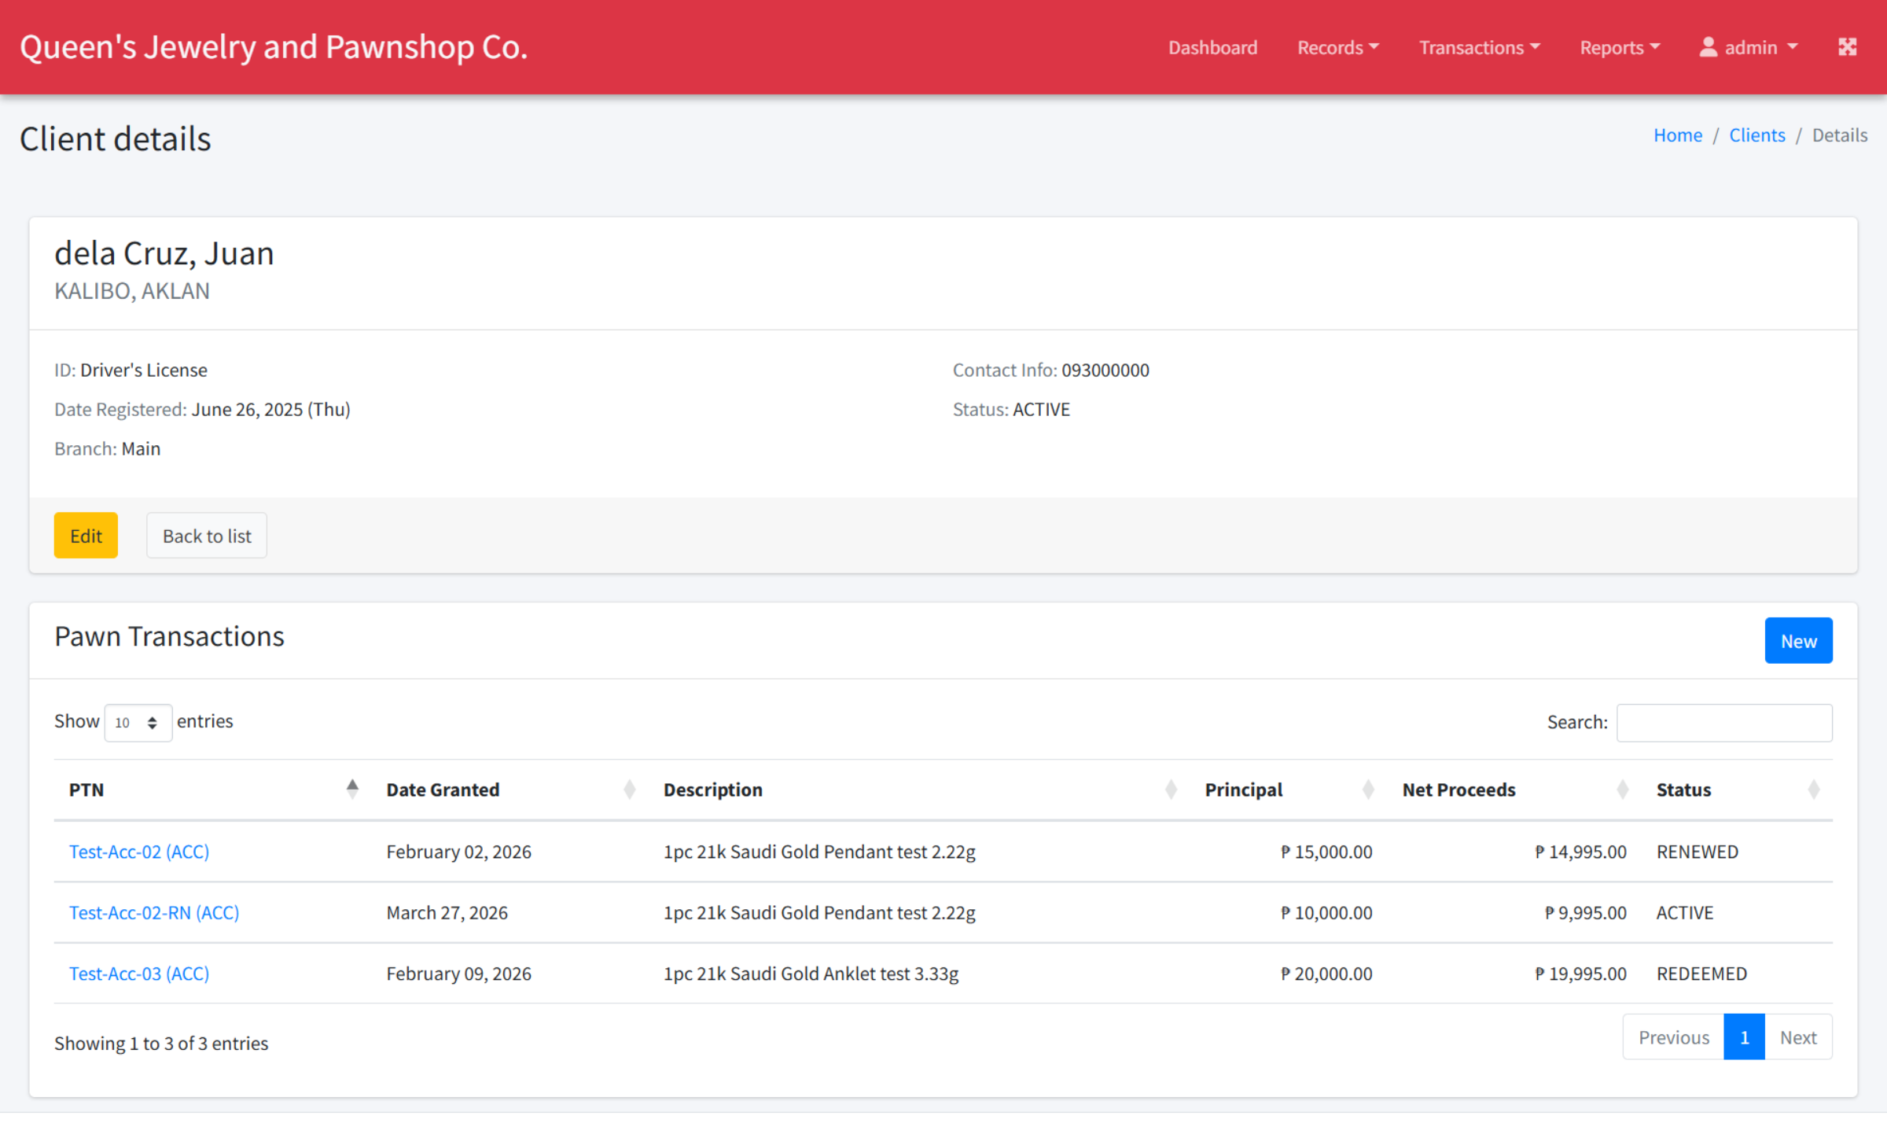
  - Use the Edit button to update the record.
  - You can directly create a new ticket from here by clicking the New button on the right of the Pawn Transactions panel (see Pawn Tickets).
  - You may also view an existing ticket by clicking the PTN under the Pawn Transaction panel.

Pawn Tickets
To prevent duplicating client records and increase accuracy and efficiency when creating a new ticket, the followings steps are highly recommended:
- Navigate to the Clients list by clicking Records > Clients.
- Using the search functionality, see if the client already exists in the system or not. 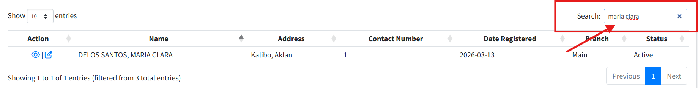
  - If the client exists, click on the Details link to open client details.
  - If the client doesn’t exist, click on the New button and proceed to adding the client. After saving, you should be navigated to the Details page.
- From the details page, verify that the ticket is not yet existing by using the search functionality. If it is a new one, click the New button. The New Pawn form will be shown.
- Accrued interest will use rates depending on when the ticket is renewed or redeemed. The only deduction here will be the service charge. 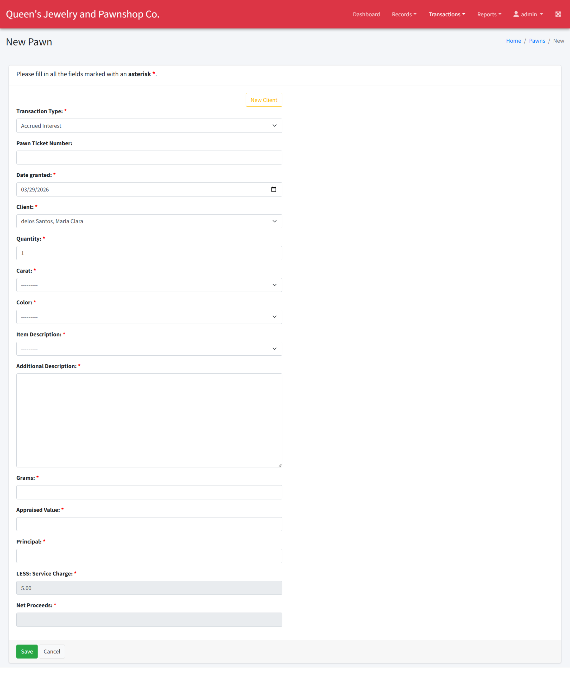
  - Select “Accrued Interest” from the Transaction Type.
  - For the Pawn Ticket Number, enter the number reflected in the manual ticket.
  - Date Granted should contain the actual date when the transaction was done. Although it shows the current date by default, you may modify it for late encoding.
  - The Client field must be selected at this time. However, if you choose to make a pawn ticket from the Pawn Ticket list, you will have to search for the client’s name here.
  - Enter the rest of the required fields.
  - Click the Save button. You should be navigated to the Pawn details page.
- Advanced interest will use the advanced interest rates provided. The total deduction will be the service charge plus the advance interest. 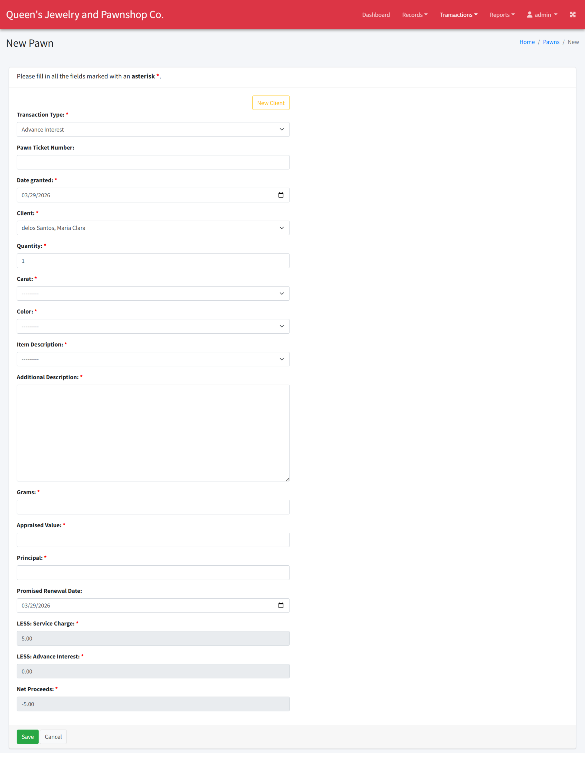
  - Select “Advance Interest” from the Transaction Type.
  - For the Pawn Ticket Number, enter the number reflected in the manual ticket.
  - Date Granted should contain the actual date when the transaction was done. Although it shows the current date by default, you may modify it for late encoding.
  - The Client field must be selected at this time. However, if you choose to make a pawn ticket from the Pawn Ticket list, you will have to search for the client’s name here.
  - Enter the rest of the required fields.
  - The Promised Renewal Date is most useful when the rate varies depending on when the ticket will be renewed or redeemed. If only one rate is being used, please select the maturity date.
  - Click the Save button. You should be navigated to the Pawn details page.

Pawn List
This list allows the user to view all the pawn records within their designated branch or from all branches.
- Navigate to Transactions > Pawn Tickets. 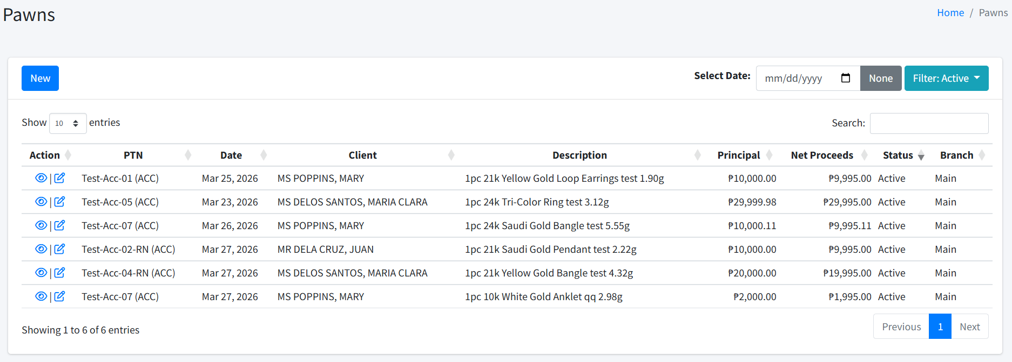
- You may filter the list by selecting a specific date and/or by choosing which status to display. You may also search for a particular pawn ticket number or description using the search box.
- To add a new pawn ticket, click the New button. However, this is not the recommended way.
- To view the pawn’s details, click on the Detail icon under Action column.
- If the ticket was created within the day, or if the user is an administrator, you may edit the ticket by clicking on the Edit icon under the Action column.

Pawn details
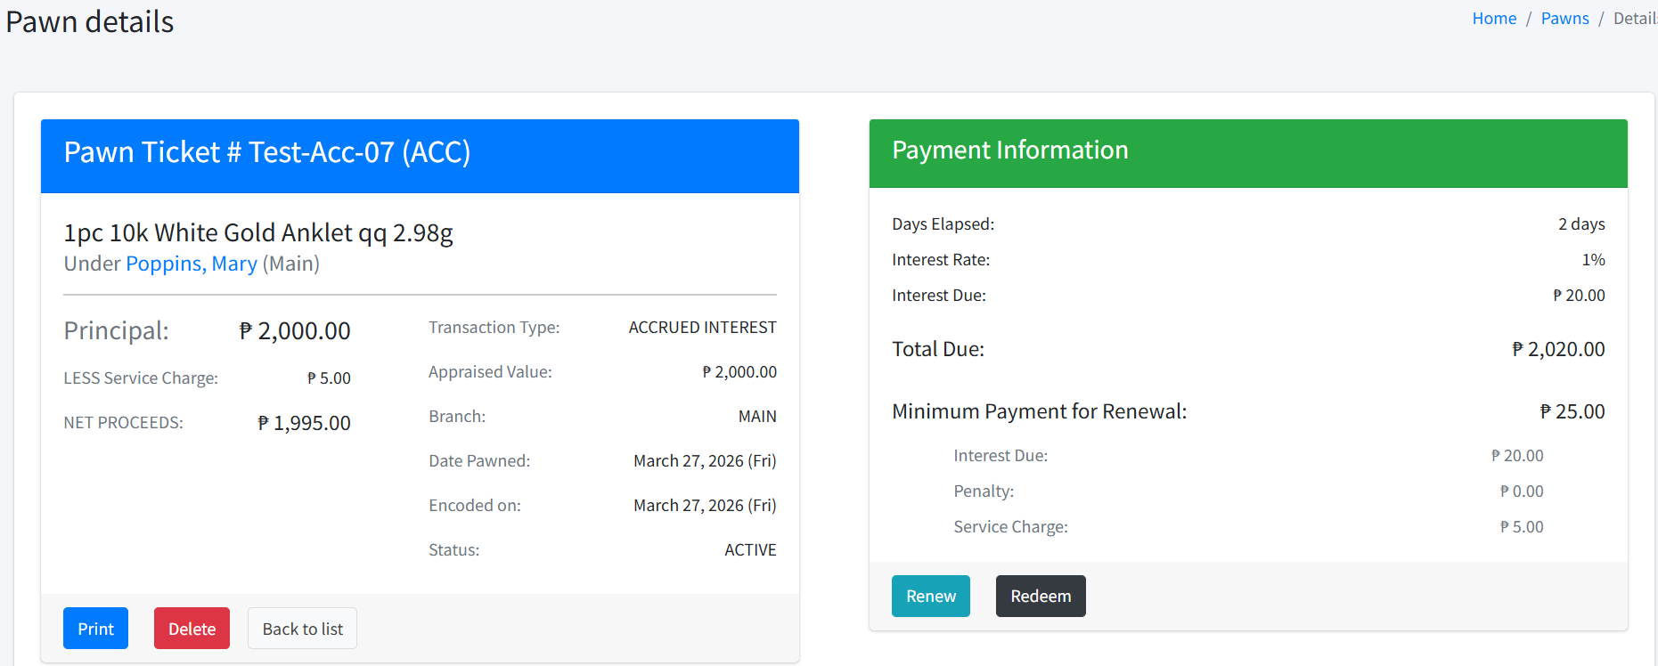
The pawn details page is a central hub to all ticket-related transactions as shown in the image above. Here’s the description of what the buttons do:
- Print: This will open a page with the pawn ticket details for easy printing.
- Delete: This option will only be available for active tickets and if the user is an administrator. Clicking on this button will delete the ticket itself.
- Void: This option is available for administrators, and if the ticket has been redeemed or auctioned.
- Renew: Opens the Renew ticket form to allow ticket renewal. It closes this ticket and creates a new one. (See Renew ticket.)
- Redeem: Opens the Redeem ticket form. Doing so will close this ticket and remove the item from the inventory. (See Redeem ticket.)

Renew ticket
- Open the details page of a ticket and click the Renew button. The Renew ticket form will be displayed. 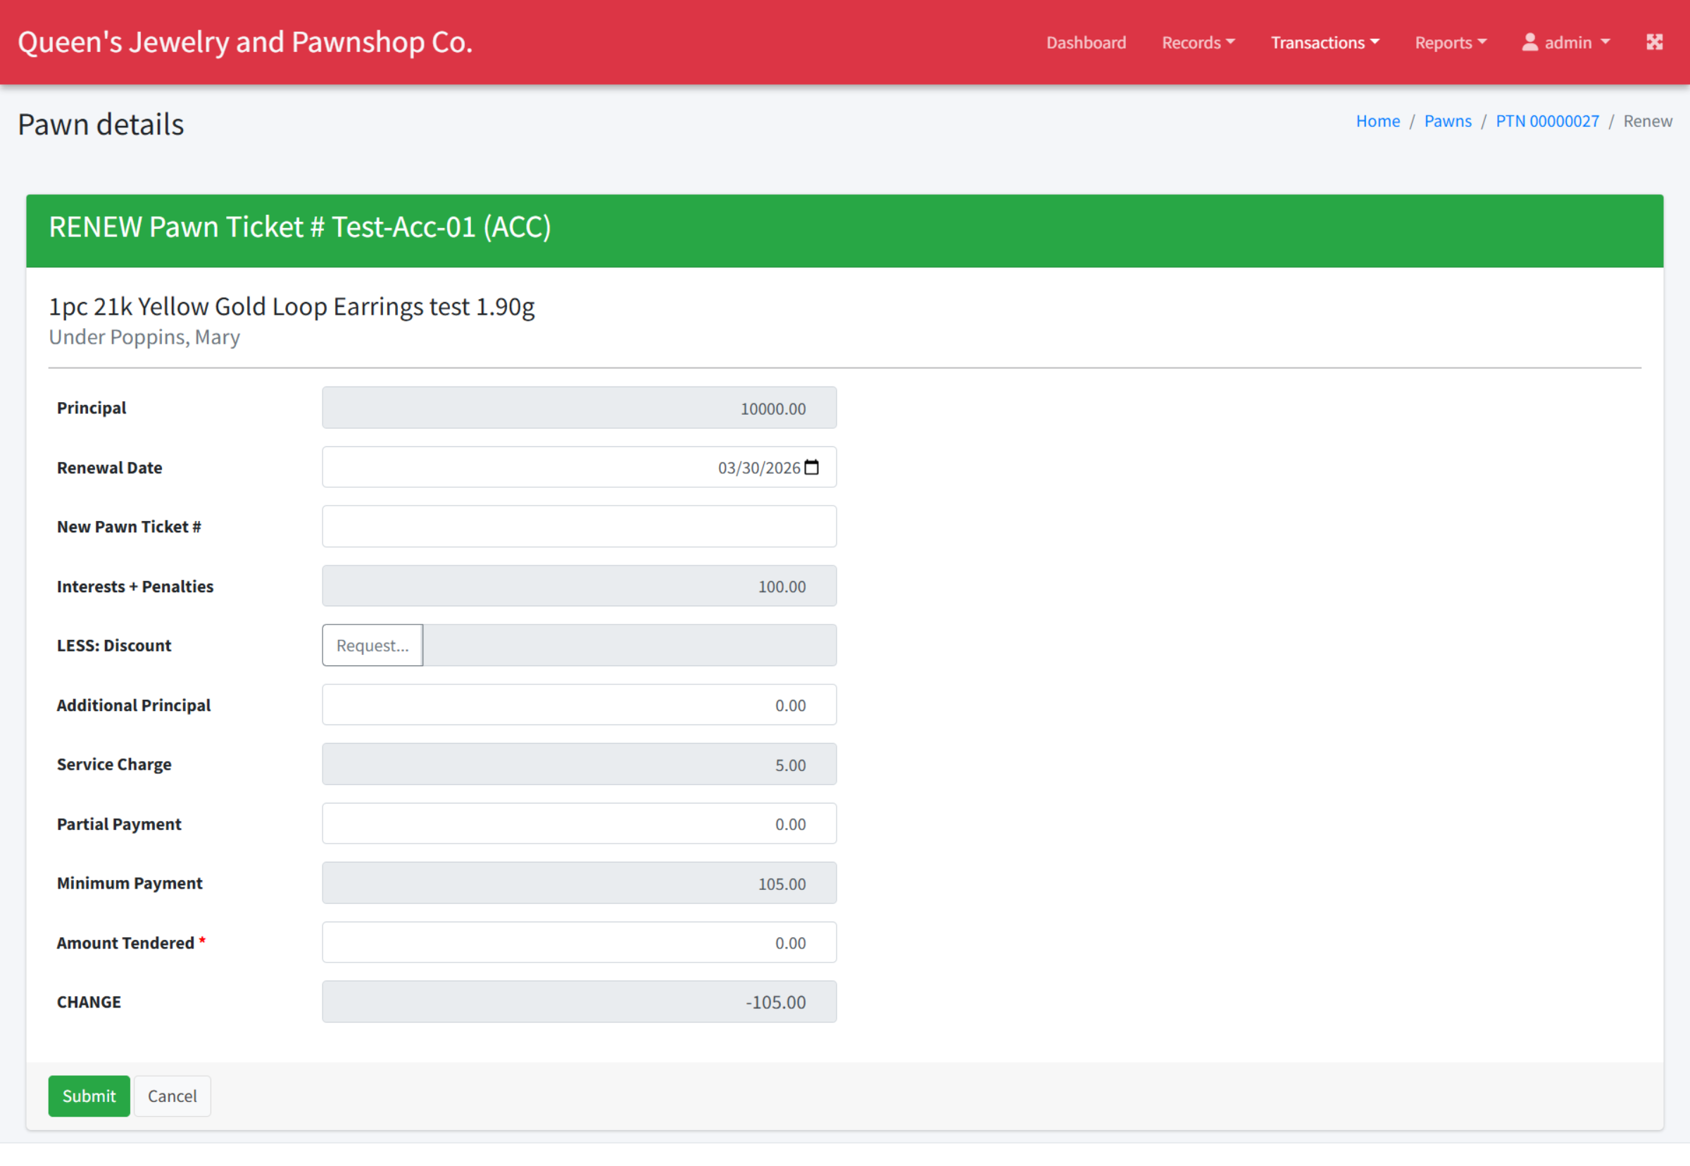
- Fill in the required information, making sure that the Renewal Date is accurate. Also, note that if the parent ticket is based on advanced interest, you will also be asked for the promised renewal date.
- Enter the Amount Tendered and then click Submit. It should open the ticket details again. Notice that a Renewed to field will be available, which links to the newly-created ticket. 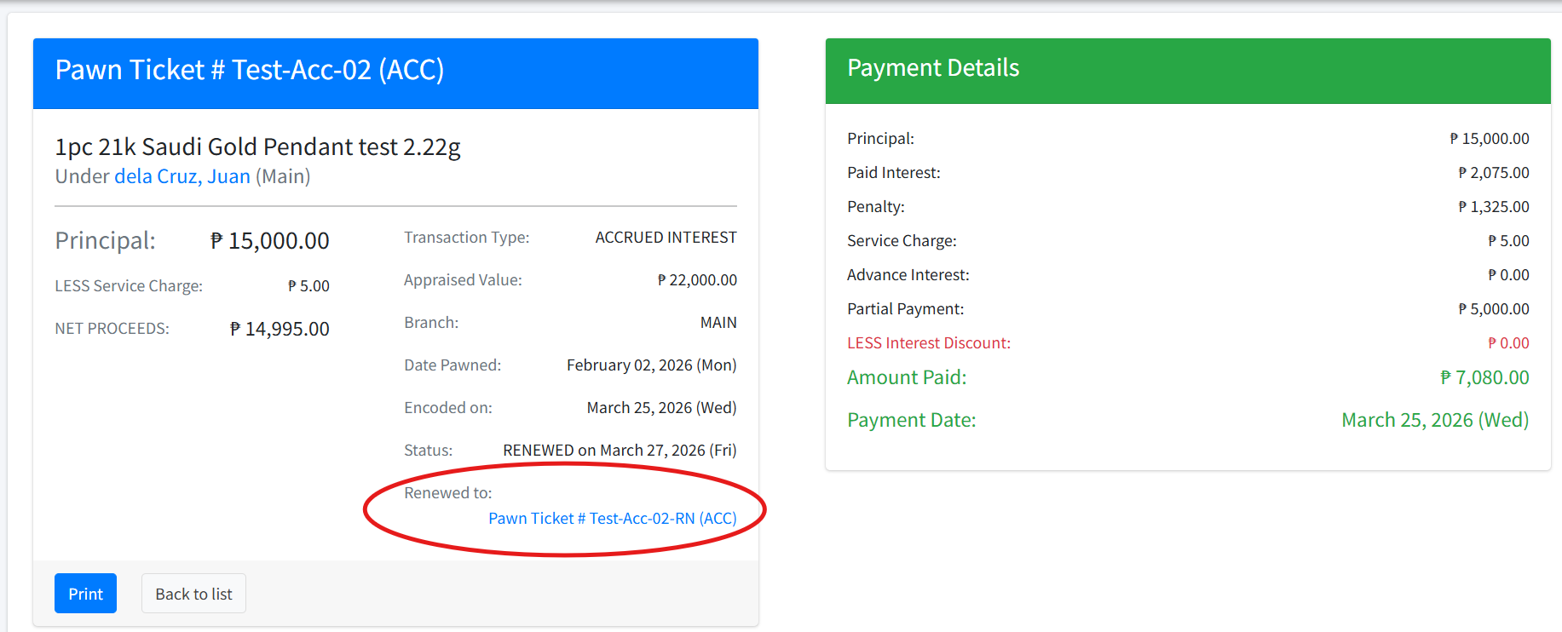

Redeem ticket
- Open the details page of a ticket and click the Redeem button. The Renew ticket form will be displayed. 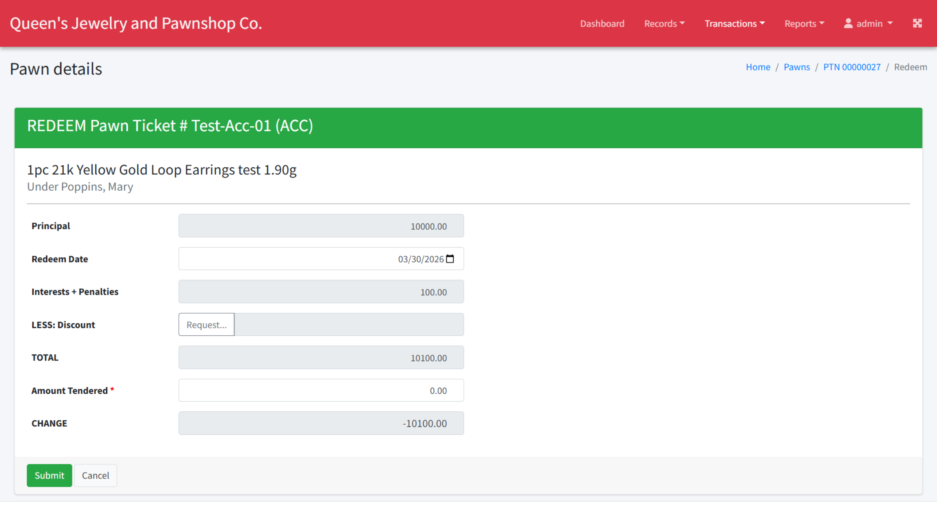
- Fill in the required information, making sure that the Redeem Date is accurate.
- Enter the Amount Tendered and then click Submit. It should open the ticket details again. Notice that Void Redeem button will be available (for administrators only), which allows administrators to void the transaction and set the ticket to active again. 